**DATABASE MANGAEMNET INTERN**

as a part of

presenting TASK 2

Submitted By:

Shafak

Date: 14 Jan. 25

**Develop a database for entity movie rental. This project involves more queries and database design. Write SQL queries to handle customer orders.**

Designing and implementing a relational database for a **Movie Rental System** involves several steps, including defining the requirements, designing the schema, and implementing the database. Below is a comprehensive guide to help you through this process:

**Step 1: Requirements Gathering**

Before designing the database, we need to identify the key entities, their attributes, and the relationships between them. Here are the common requirements for a Movie Rental System:

**Key Entities and Their Attributes**

1. **Movies**
   * **Attributes:**
     + **movie_id:** Unique identifier for each movie (Primary Key)
     + **title:** Title of the movie
     + **genre:** Genre of the movie (e.g., Action, Comedy, Drama)
     + **release_year:** Year the movie was released
     + **rating:** Rating of the movie (e.g., PG, PG-13, R)
     + **available_copies:** Number of copies available for rent
     + **duration:** Duration of the movie (in minutes)
     + **description:** Brief description or synopsis of the movie
2. **Customers**
   * **Attributes:**
     + **customer_id:** Unique identifier for each customer (Primary Key)
     + **first_name:** First name of the customer
     + **last_name**: Last name of the customer
     + **email:** Email address of the customer (Unique)
     + **phone:** Contact number of the customer
     + **address:** Residential address of the customer
     + **membership_status:** Status of the customer's membership (e.g., Active, Inactive)
3. **Rentals**
   * **Attributes:**
     + **rental_id:** Unique identifier for each rental transaction (Primary Key)
     + **customer_id:** Identifier for the customer who rented the movie (Foreign Key)
     + **movie_id:** Identifier for the rented movie (Foreign Key)
     + **rental_date:** Date and time when the movie was rented
     + **return_date:** Date and time when the movie was returned
     + **due_date:** Date by which the movie should be returned
     + **status:** Status of the rental (e.g., Rented, Returned, Overdue)
4. **Payments**
   * **Attributes:**
     + **payment_id:** Unique identifier for each payment transaction (Primary Key)
     + **rental_id:** Identifier for the rental associated with the payment (Foreign Key)
     + **amount:** Amount paid for the rental
     + **payment_date:** Date and time when the payment was made
     + **payment_method:** Method of payment (e.g., Credit Card, PayPal, Cash)
5. **Categories**
   * **Attributes:**
     + **category_id:** Unique identifier for each category (Primary Key)
     + **category_name:** Name of the category (e.g., Action, Comedy, Drama)
6. **Movie_Categories (Join Table)**
   * **Attributes:**
     + **movie_id:** Identifier for the movie (Foreign Key)
     + **category_id:** Identifier for the category (Foreign Key)

**Relationships**

1. **Movies and Categories**
   * A movie can belong to multiple categories, and a category can have multiple movies. This is a many-to-many relationship, which will be implemented using a join table called Movie_Categories.
2. **Customers and Rentals**
   * A customer can rent multiple movies, but each rental is associated with only one customer. This is a one-to-many relationship.
3. **Movies and Rentals**
   * A movie can be rented multiple times, but each rental is associated with only one movie. This is a one-to-many relationship.
4. **Rentals and Payments**
   * Each rental can have one payment associated with it, but a payment is linked to only one rental. This is a one-to-one relationship.
5. **Movies and Actors (Optional)**
   * 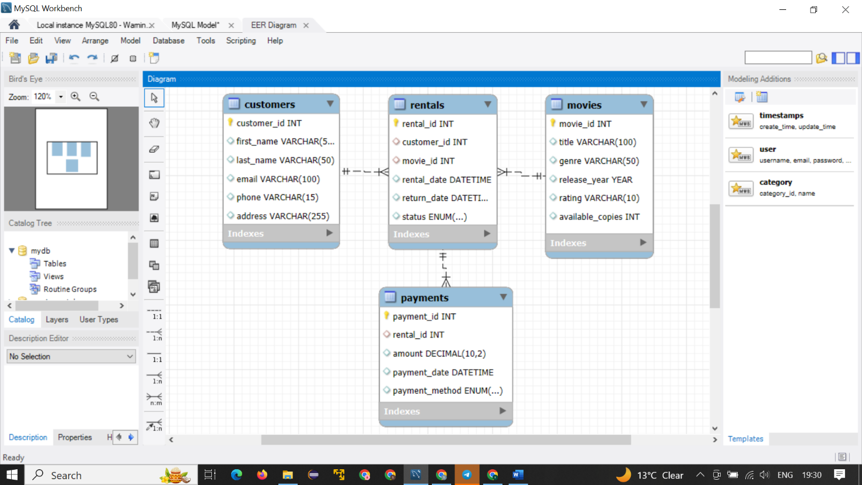If we want to include actors, we can add an Actors table with a many-to-many relationship to Movies.

**Step 2: Database Schema Design**

Based on the requirements gathered, we can design the database schema. Below is the SQL code to create the necessary tables:

1. **Create the Database**

CREATE DATABASE movie_rental;

USE movie_rental;

1. **Create the Tables**

CREATE TABLE Customers (

customer_id INT AUTO_INCREMENT PRIMARY KEY,

first_name VARCHAR(50),

last_name VARCHAR(50),

email VARCHAR(100) UNIQUE,

phone VARCHAR(15),

address VARCHAR(255)

membership_status ENUM('Active', 'Inactive')

);

CREATE TABLE Movies (

movie_id INT AUTO_INCREMENT PRIMARY KEY,

title VARCHAR(100),

genre VARCHAR(50),

release_year YEAR,

rating VARCHAR(10),

available_copies INT

);

CREATE TABLE Rentals (

rental_id INT AUTO_INCREMENT PRIMARY KEY,

customer_id INT,

movie_id INT,

rental_date DATETIME,

return_date DATETIME,

status ENUM('rented', 'returned'),

FOREIGN KEY (customer_id) REFERENCES Customers(customer_id),

FOREIGN KEY (movie_id) REFERENCES Movies(movie_id)

);

CREATE TABLE Payments (

payment_id INT AUTO_INCREMENT PRIMARY KEY,

rental_id INT,

amount DECIMAL(10, 2),

payment_date DATETIME,

payment_method ENUM('credit_card', 'paypal', 'cash'),

FOREIGN KEY (rental_id) REFERENCES Rentals(rental_id)

);

1. **Insert Sample Data**

**Insert Customers**

INSERT INTO Customers (first_name, last_name, email, phone, address) VALUES

('John', 'Doe', 'john.doe@example.com', '1234567890', '123 Elm St'),

('Jane', 'Smith', 'jane.smith@example.com', '0987654321', '456 Oak St');

**Insert Movies**

INSERT INTO Movies (title, genre, release_year, rating, available_copies) VALUES

('Inception', 'Sci-Fi', 2010, 'PG-13', 5),

('The Godfather', 'Crime', 1972, 'R', 3),

('The Dark Knight', 'Action', 2008, 'PG-13', 4);

**Insert Rentals**

INSERT INTO Rentals (customer_id, movie_id, rental_date, status) VALUES

(1, 1, NOW(), 'rented'),

(2, 2, NOW(), 'rented');

**Insert Payments**

INSERT INTO Payments (rental_id, amount, payment_date, payment_method) VALUES

(1, 4.99, NOW(), 'credit_card'),

(2, 3.99, NOW(), 'paypal');

**Step 3. Queries to Handle Customer Orders**

1. **Get All Movies Available for Rent**

SELECT * FROM Movies WHERE available_copies > 0;

1. **Rent a Movie**

Assuming customer_id and movie_id are provided

SET @customer_id = 1;

SET @movie_id = 1;

Check if the movie is available

SELECT available_copies FROM Movies WHERE movie_id = @movie_id;

If available, insert rental and update available copies

INSERT INTO Rentals (customer_id, movie_id, rental_date, status) VALUES

(@customer_id, @movie_id, NOW(), 'rented');

UPDATE Movies SET available_copies = available_copies - 1 WHERE movie_id = @movie_id;

1. **Update Customer Information**

UPDATE Customers

SET phone = '555-5678', address = '101 Maple St'

WHERE customer_id = 1; **-- Assuming customer_id 1 is the customer to update**

1. **Retrieve All Customers**

SELECT * FROM Customers;

1. **Retrieve a Specific Customer by ID**

SELECT * FROM Customers

WHERE customer_id = 1; -- Replace with the desired customer_id

1. **Retrieve Customers with Active Membership**

SELECT * FROM Customers

WHERE membership_status = 'Active';

1. **Retrieve Customer Count by Membership Status**

SELECT membership_status, COUNT(*) AS count

FROM Customers

GROUP BY membership_status;